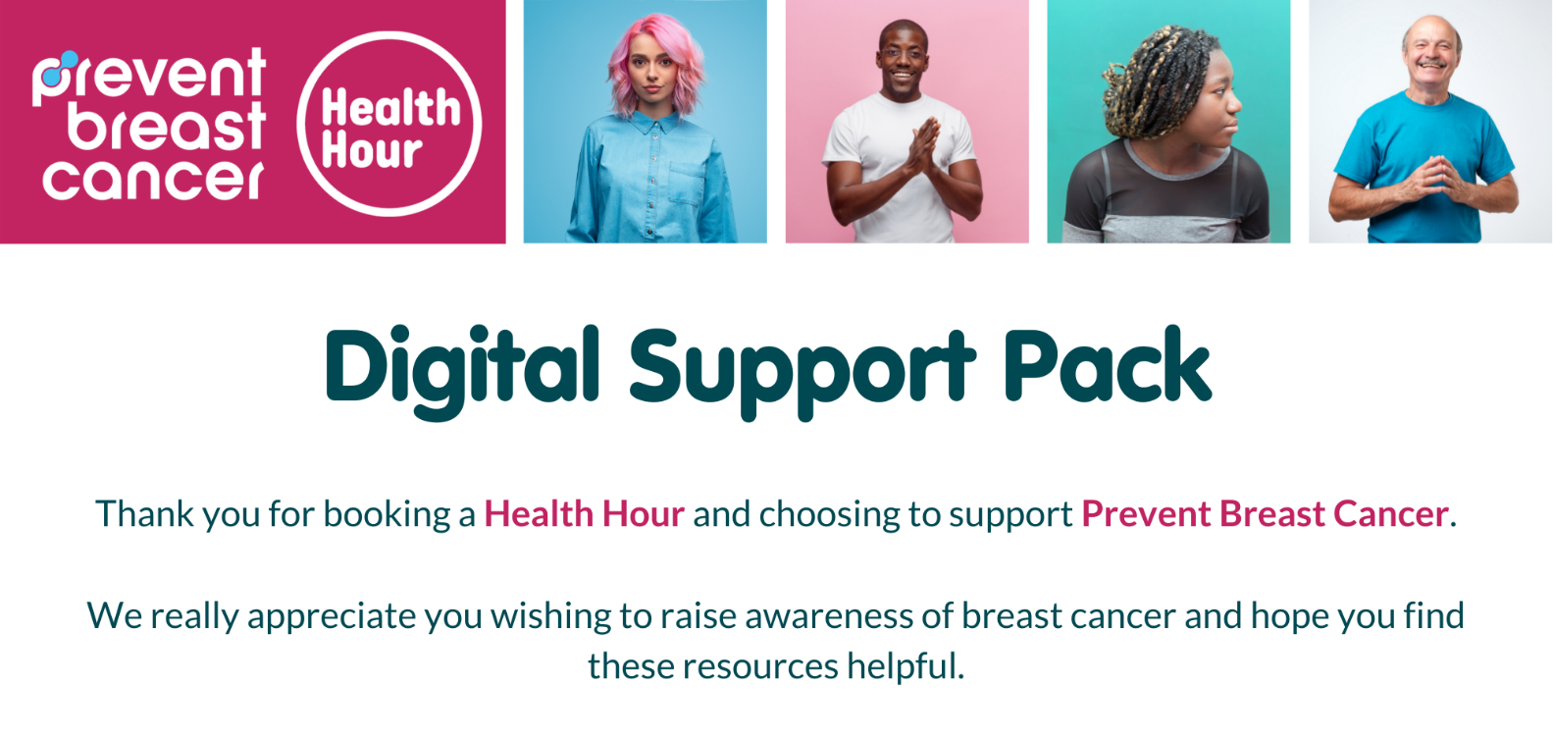
Promote your talk:
To help advertise your Health Hour event,
click here to download and edit our poster template.

Useful information to share with your employees:
- Learn ‘The Essentials: 5 points in 5 minutes’ and ‘Why we need your support’.
- Find out how to check your breasts in this video.
- Refer our Health Hour talk to a friend! Share this link.
- If you wish to donate, you can do so here.
- Stay in touch – follow us on Facebook, Instagram, Twitter and LinkedIn.
- Sign up to our newsletter here.
